2. GITHUB:

(A) CREATING THE GITHUB ACCOUNT

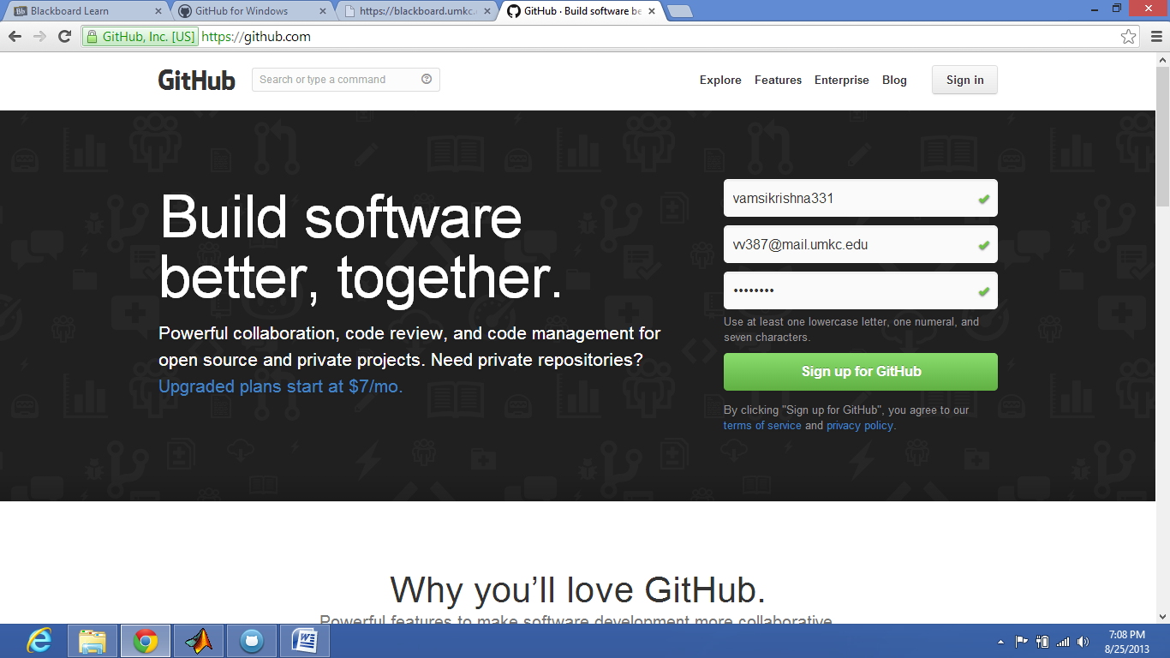

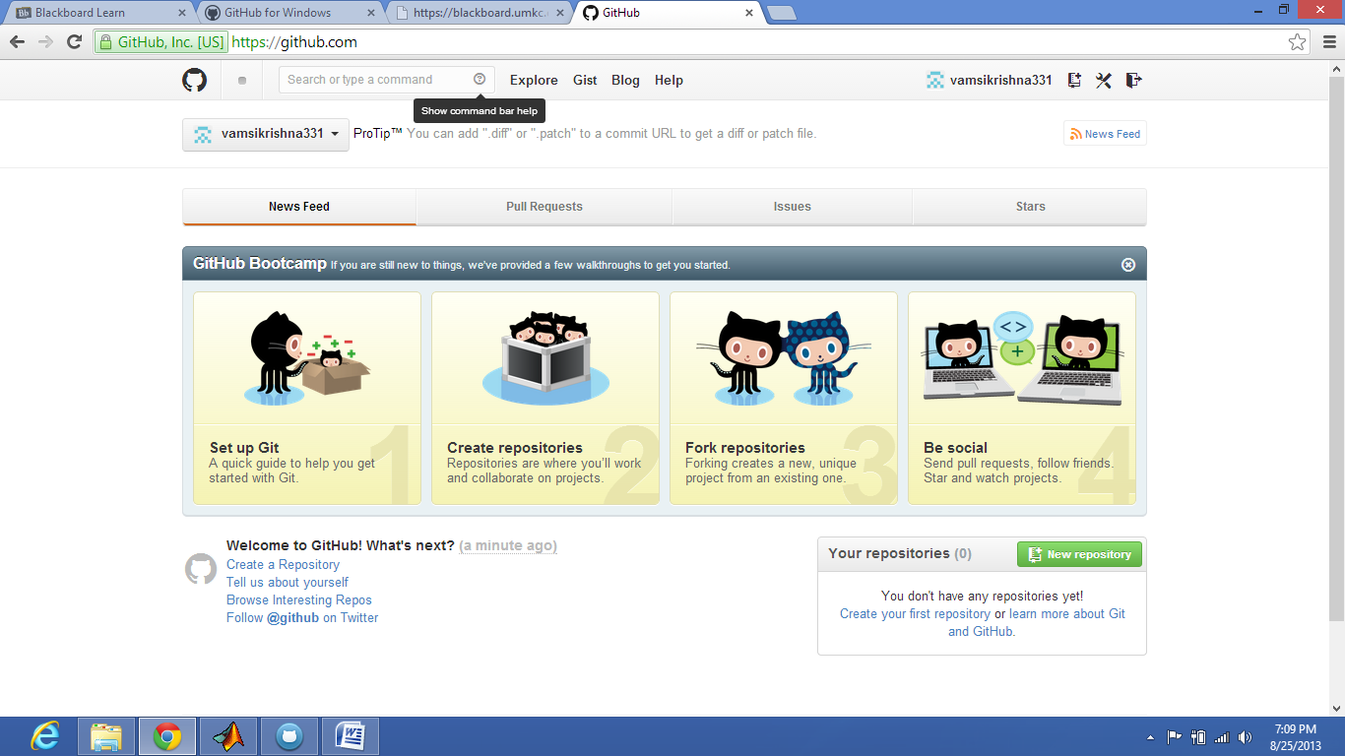

(B) CREATING THE REPOSITORY

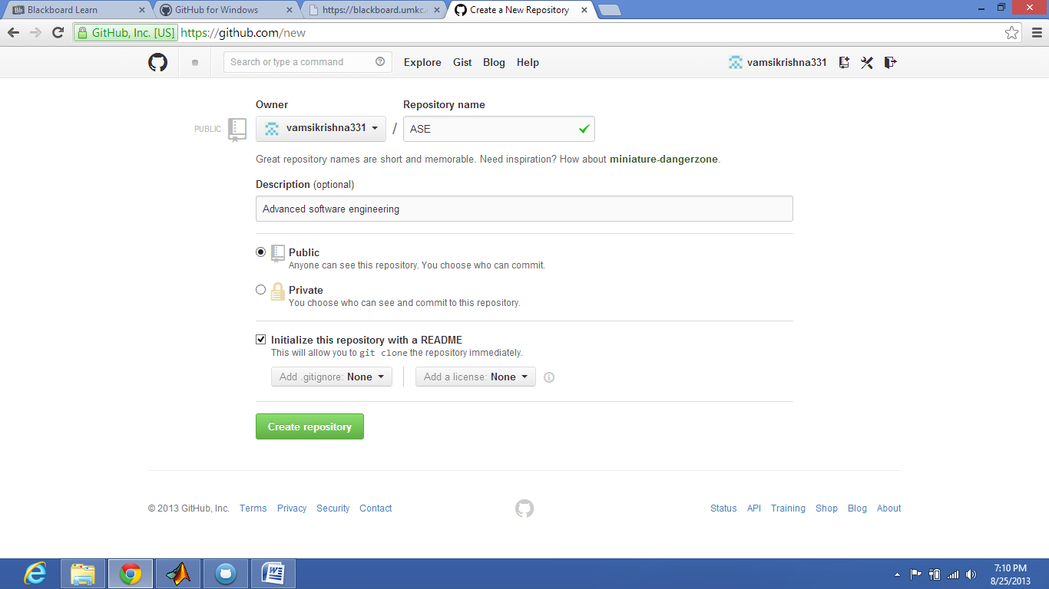

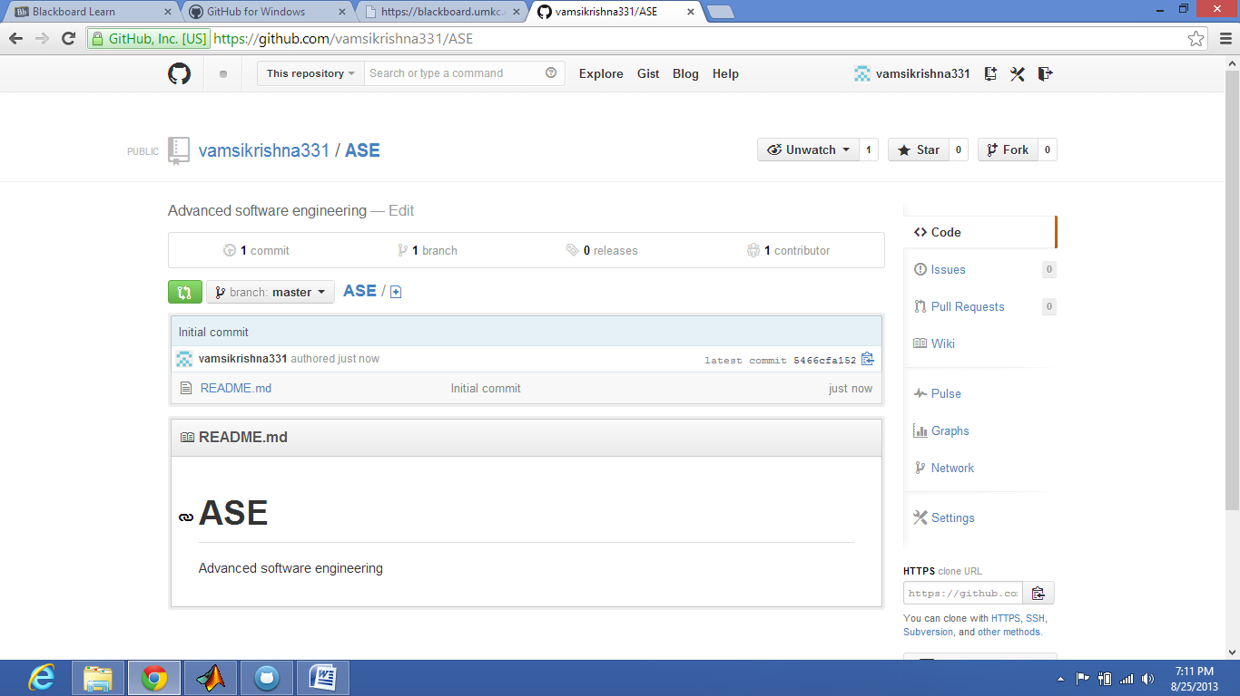

(C) LOGIN INTO THE GITHUB FOR WINDOWS

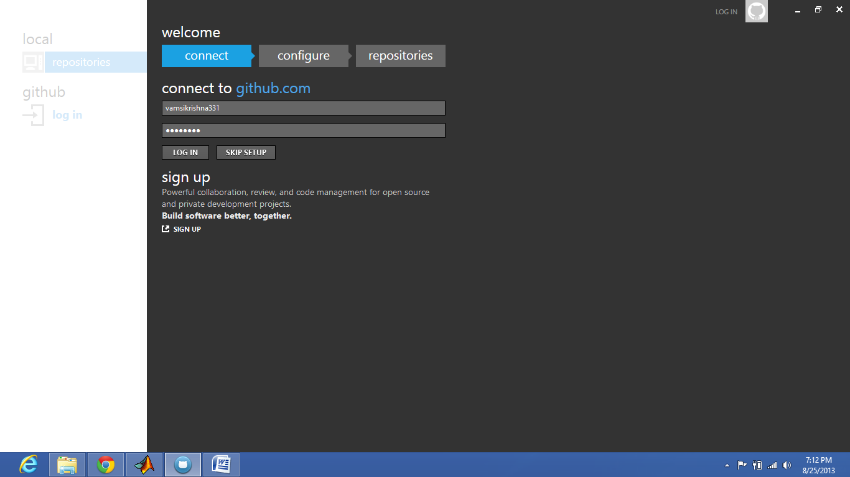

(D) CREATING THE LOCAL REPOSITORIES

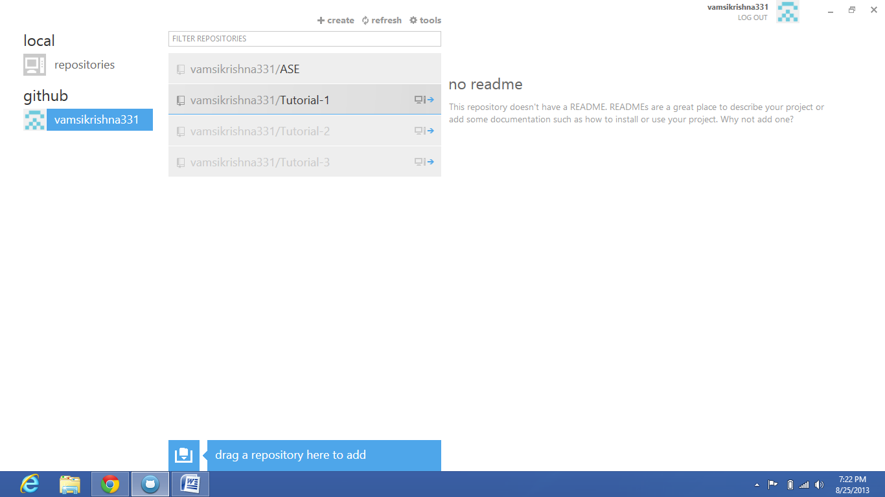

(E) CLONING THE REPOSITORY:

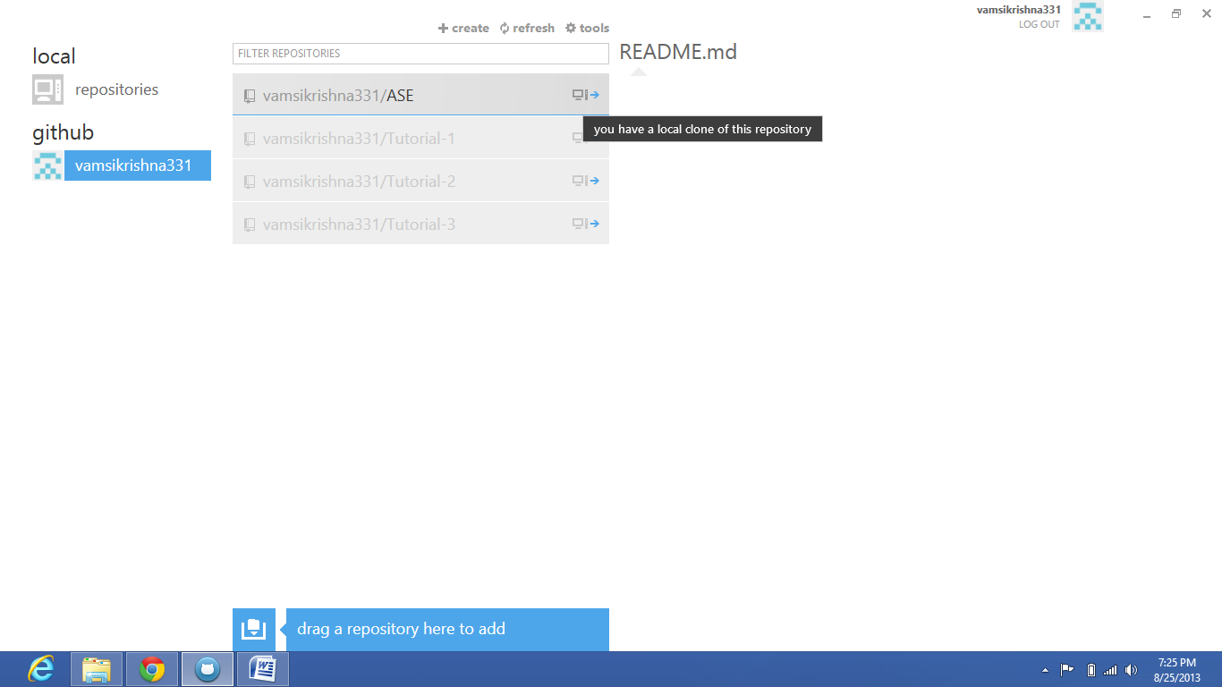

(F) GIT UNDER SOME DIRECTORY:

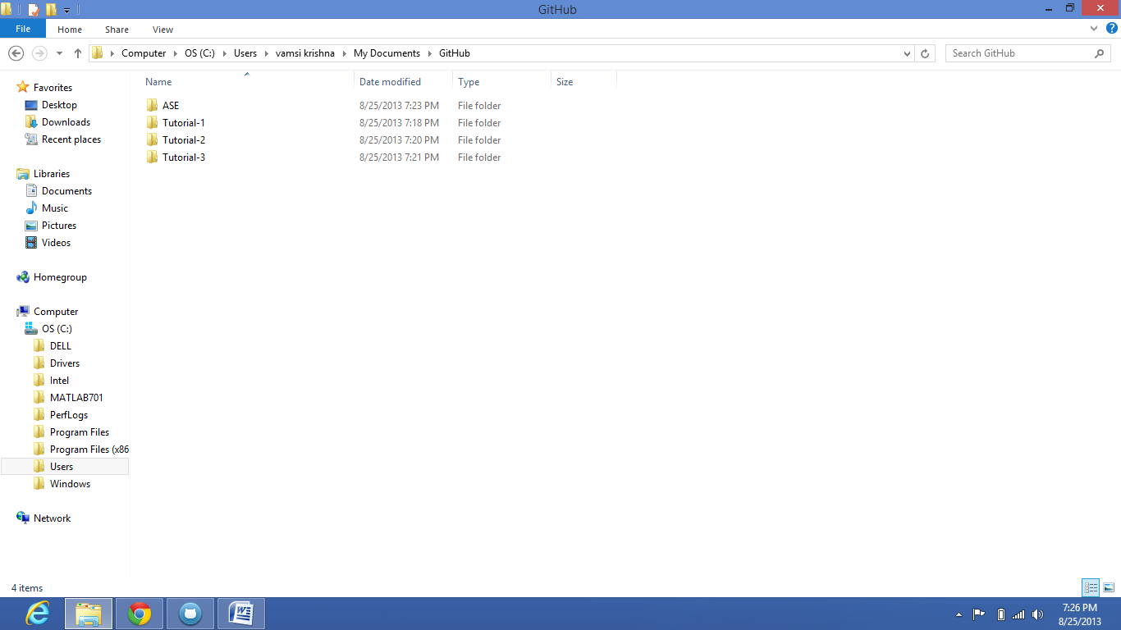

(G) MODIFY THE FILE LOCALLY

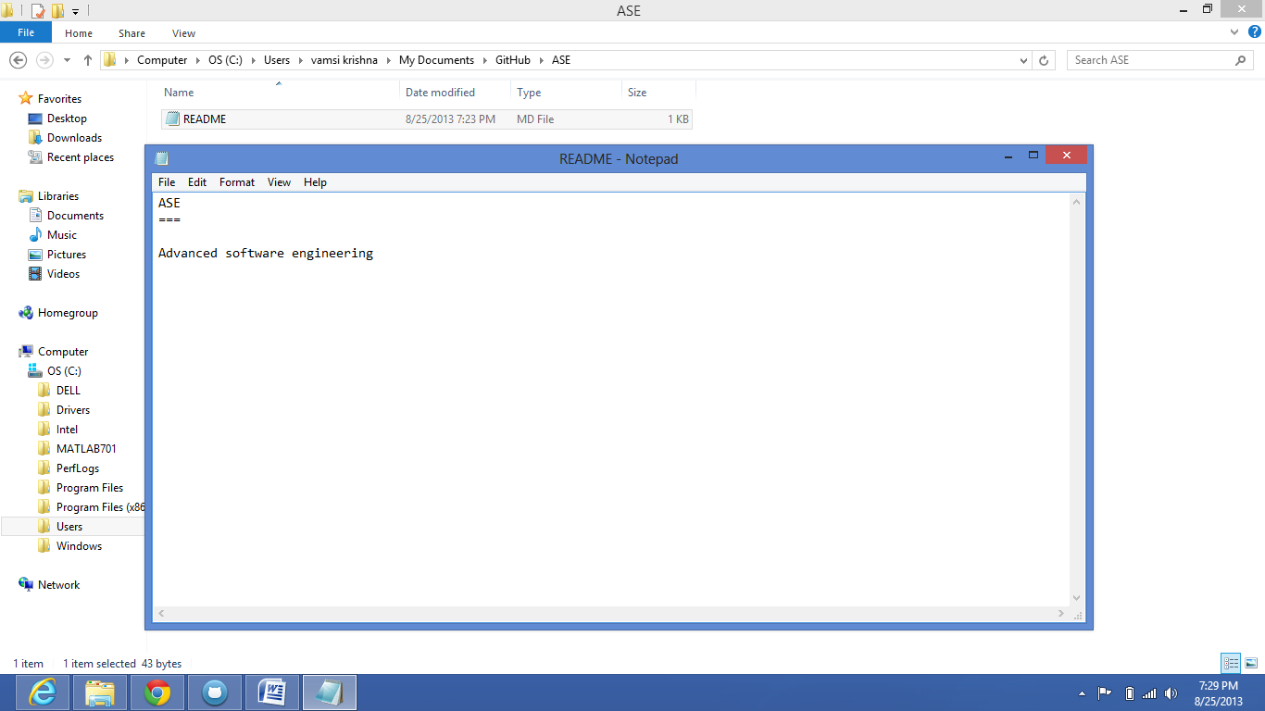

(H) UNCOMMITTED CHANGES DIALOG POP UP AND THEN IT IS PUBLISHED AND IN SYNC

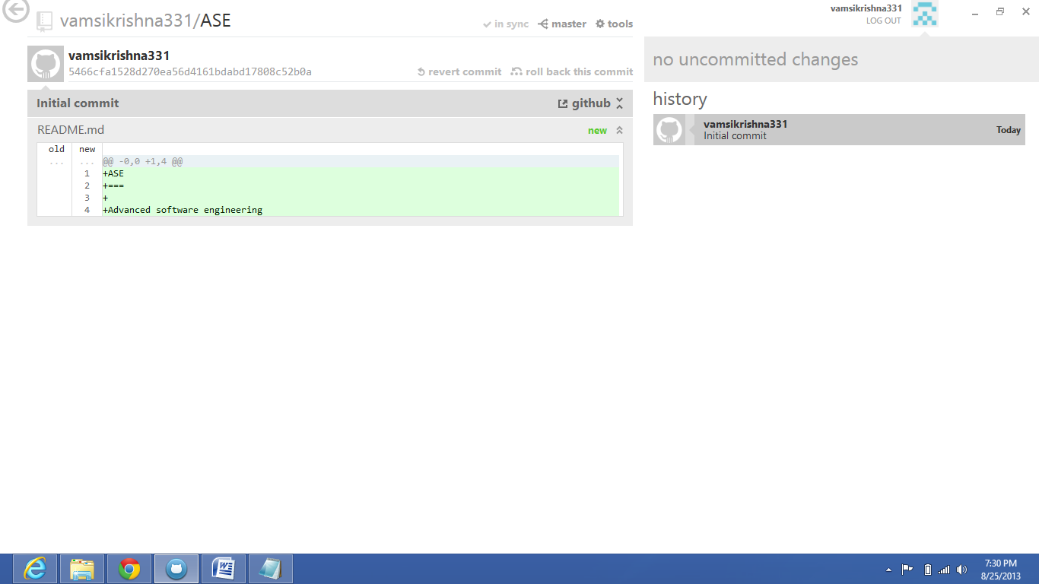

(I) TYPE IN COMMIT MESSAGE AND COMMIT AND THEN PUBLISH

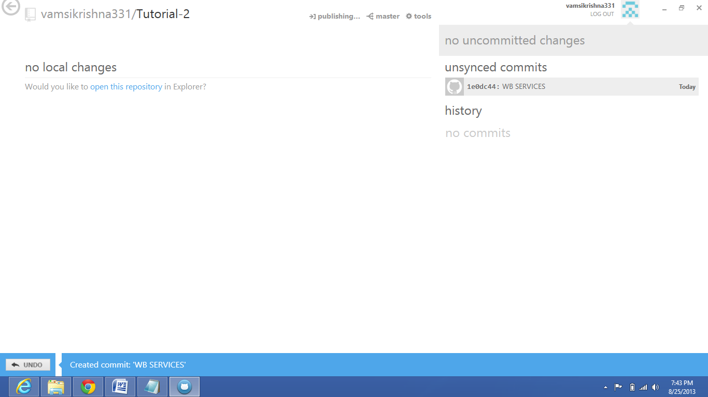

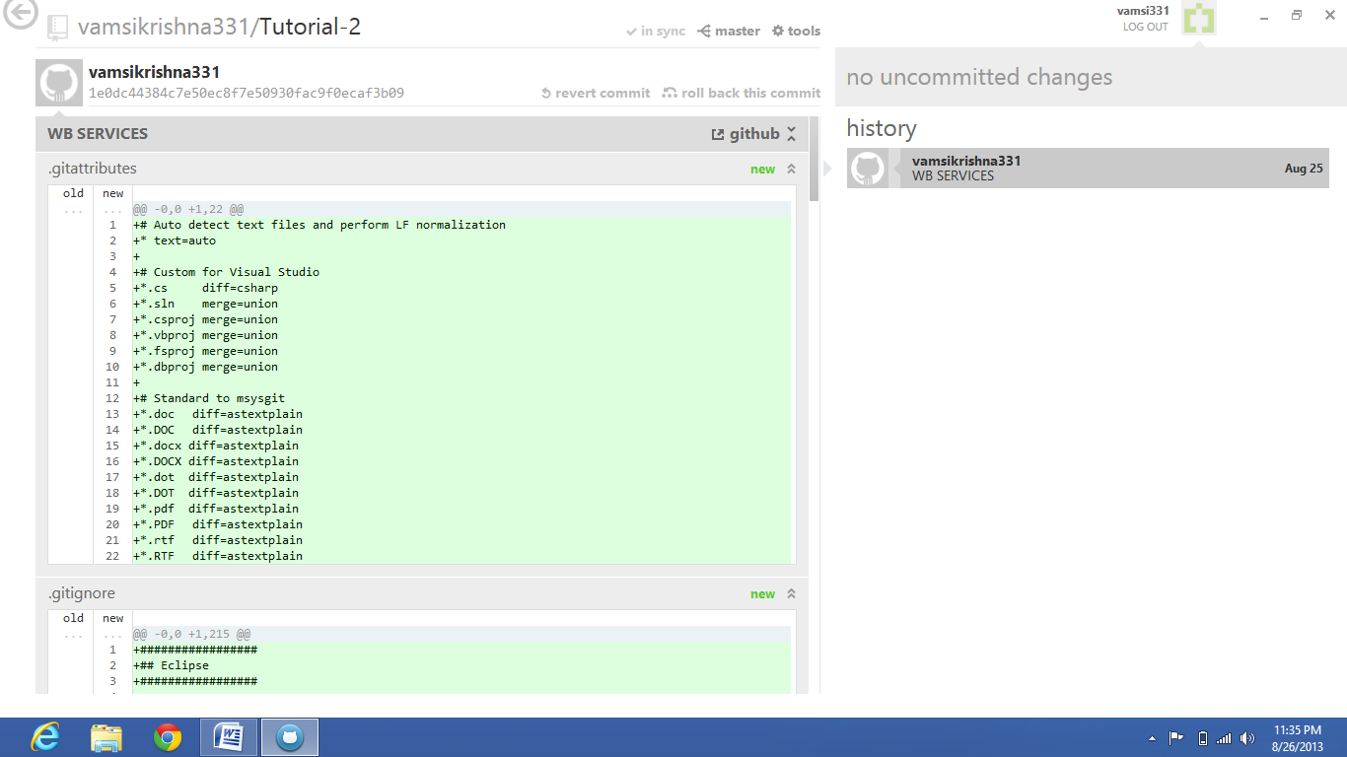

(J) ALL CONTRIBUCTIONS IN GITHUB ACCOUNT

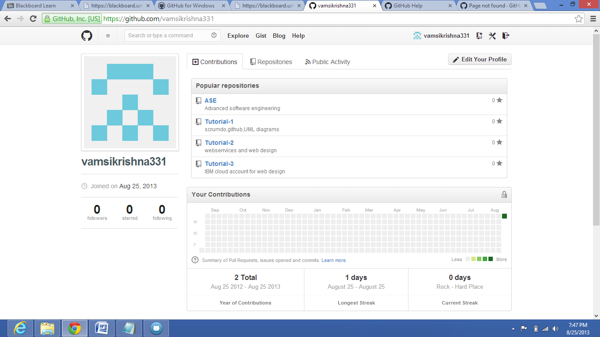

(K) ALL THE REPOSITORIES IN THE GITHUB ACCOUNT

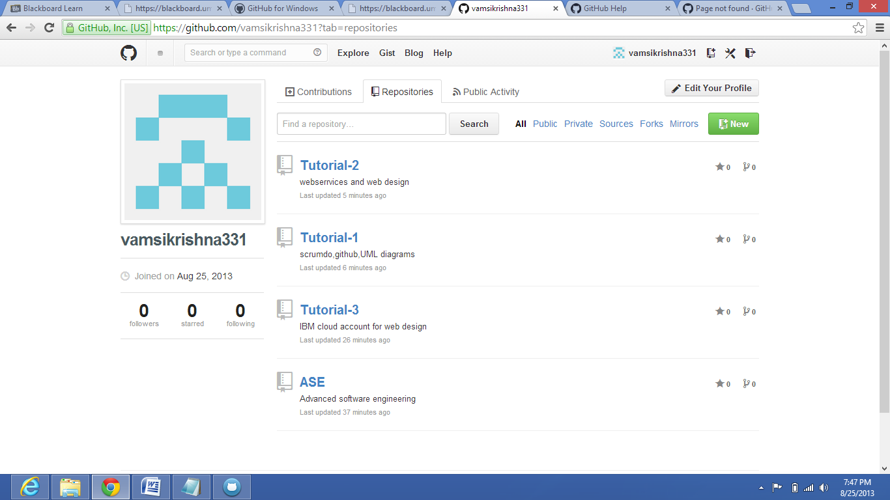

(L) ALL THE PUBLIC ACTIVITY IN THE GITHUB ACCOUNT

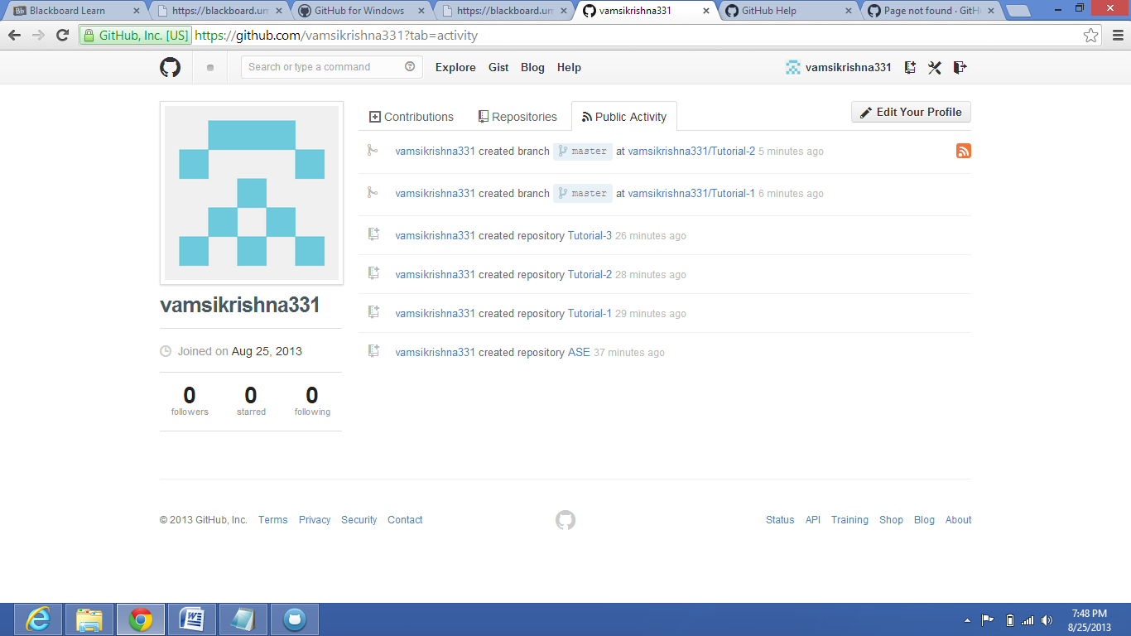

(M) CREATING THE ORGANISATIONS

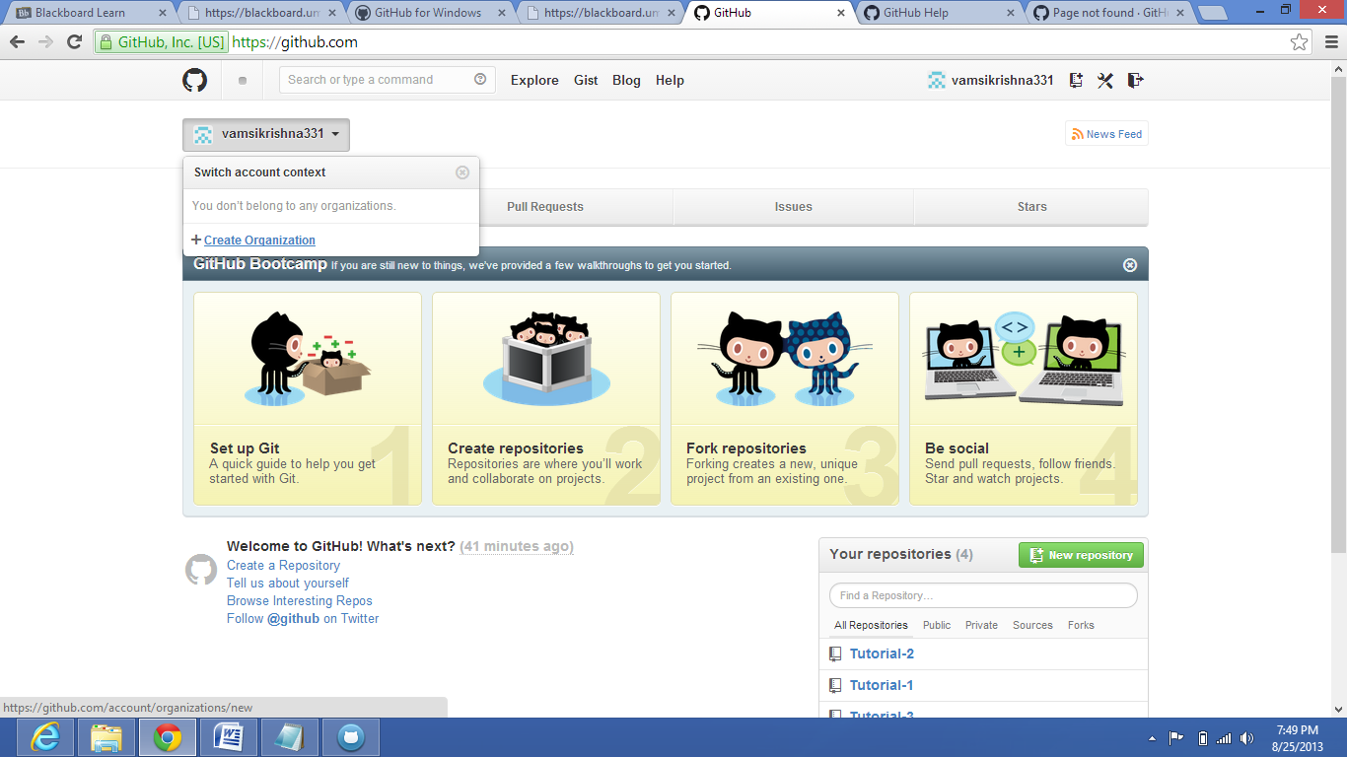

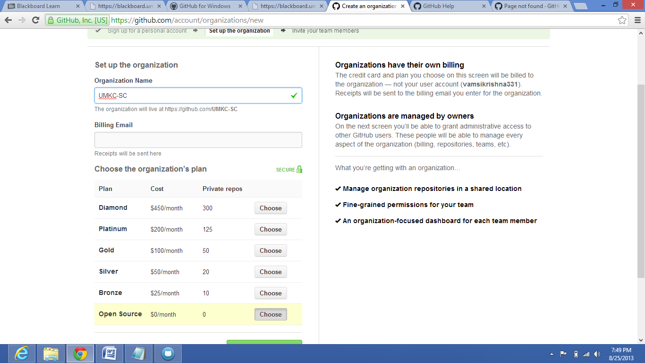

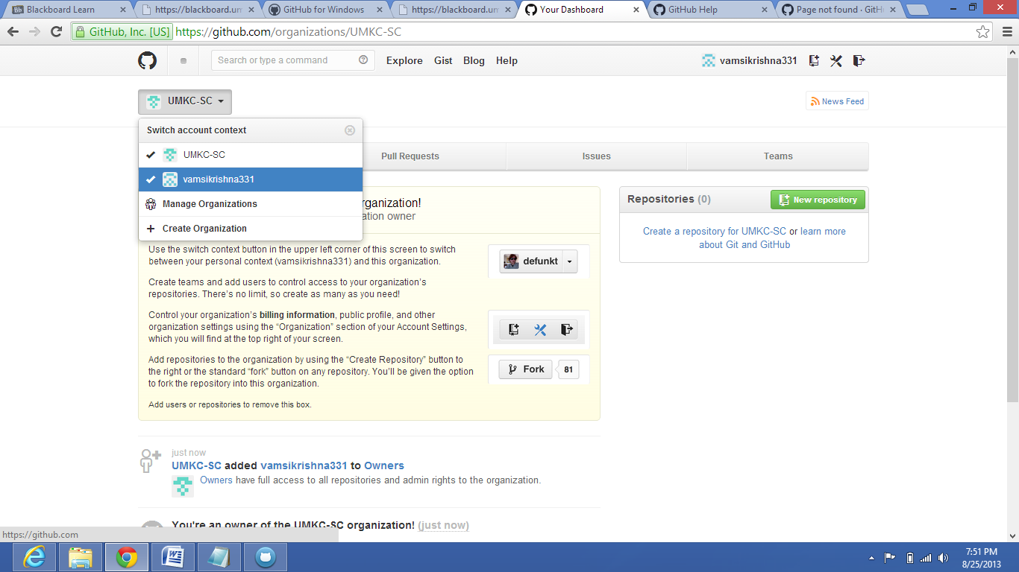

(N) ADDING THE TEAM MEMBER

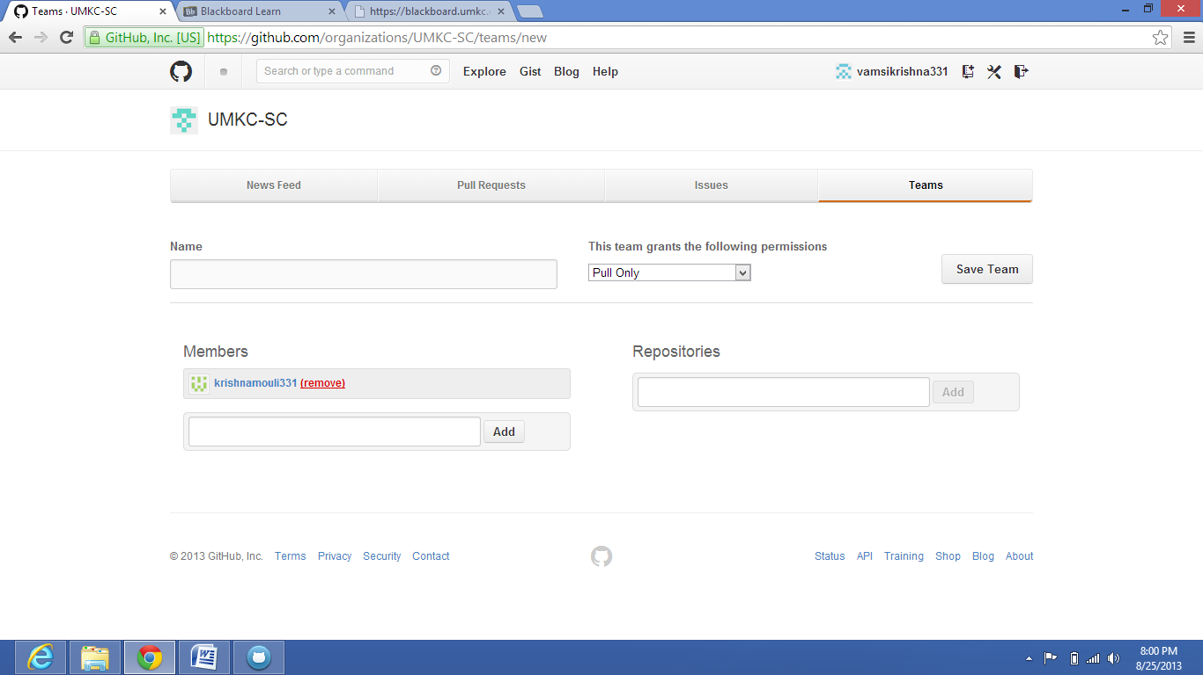

(O) LOGGING AS DIFFERENT MEMBER(krishnamouli331)

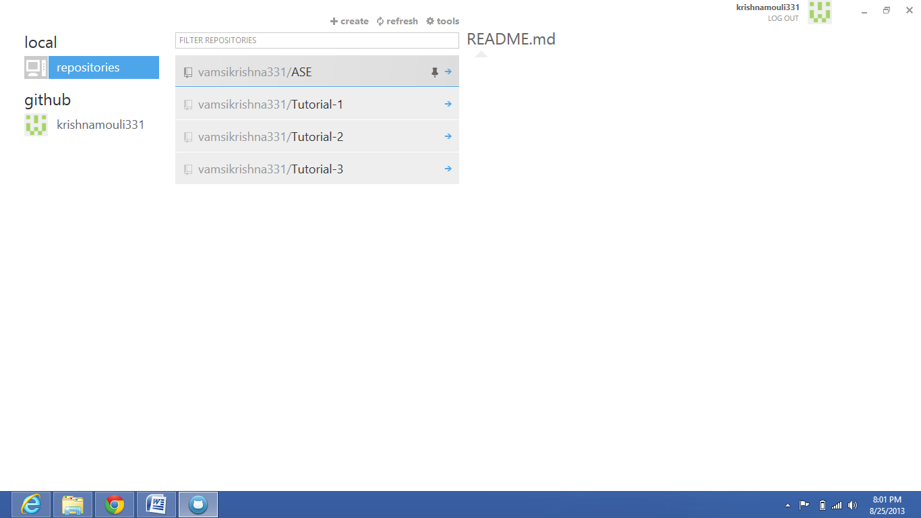

(P) CLONE ORGANISATION PROJECT BY NEW USER

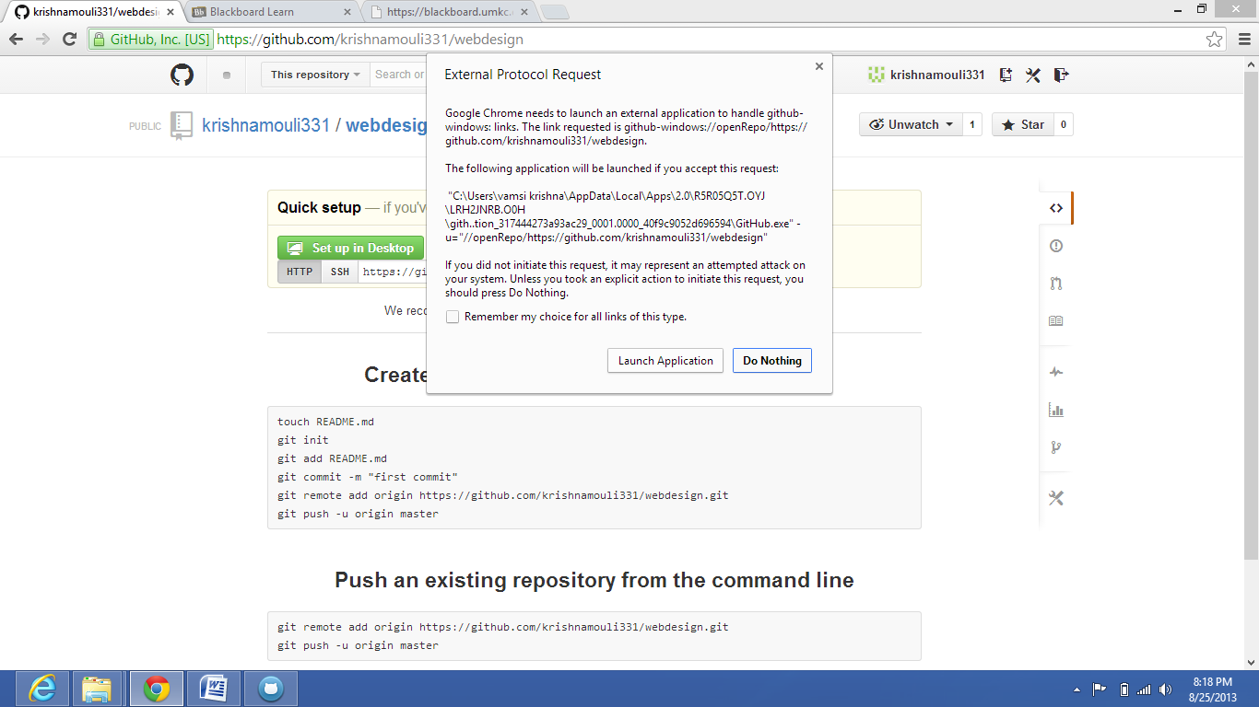

(Q) OPENING THE REPOSITORY

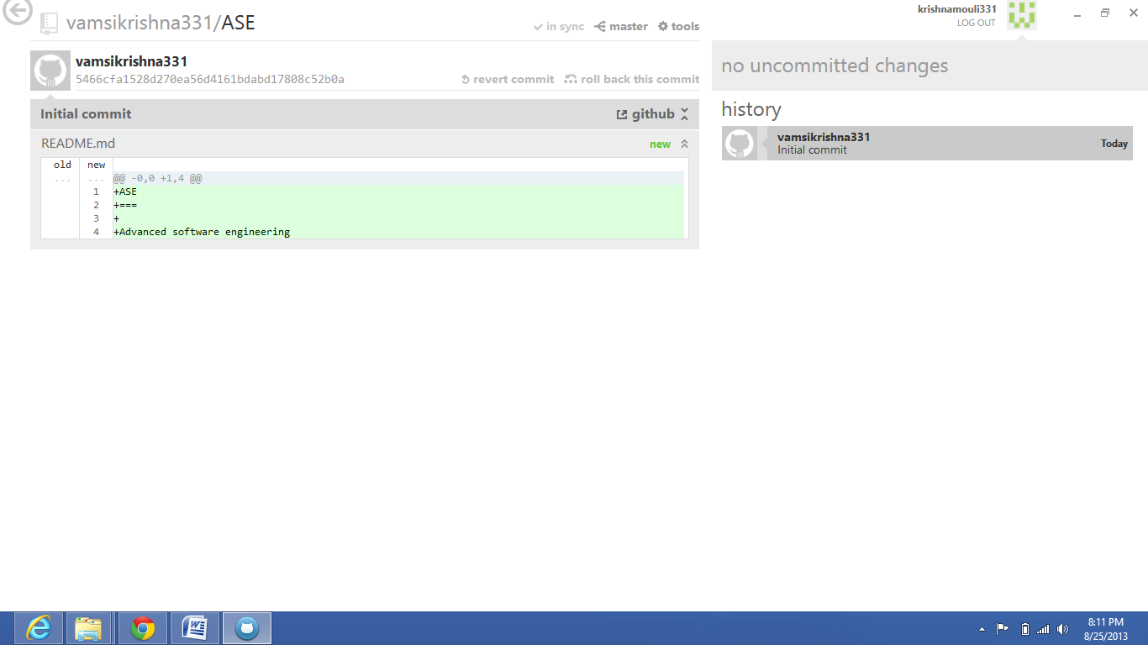

(R) ADD ONE LINE IN THE FILE

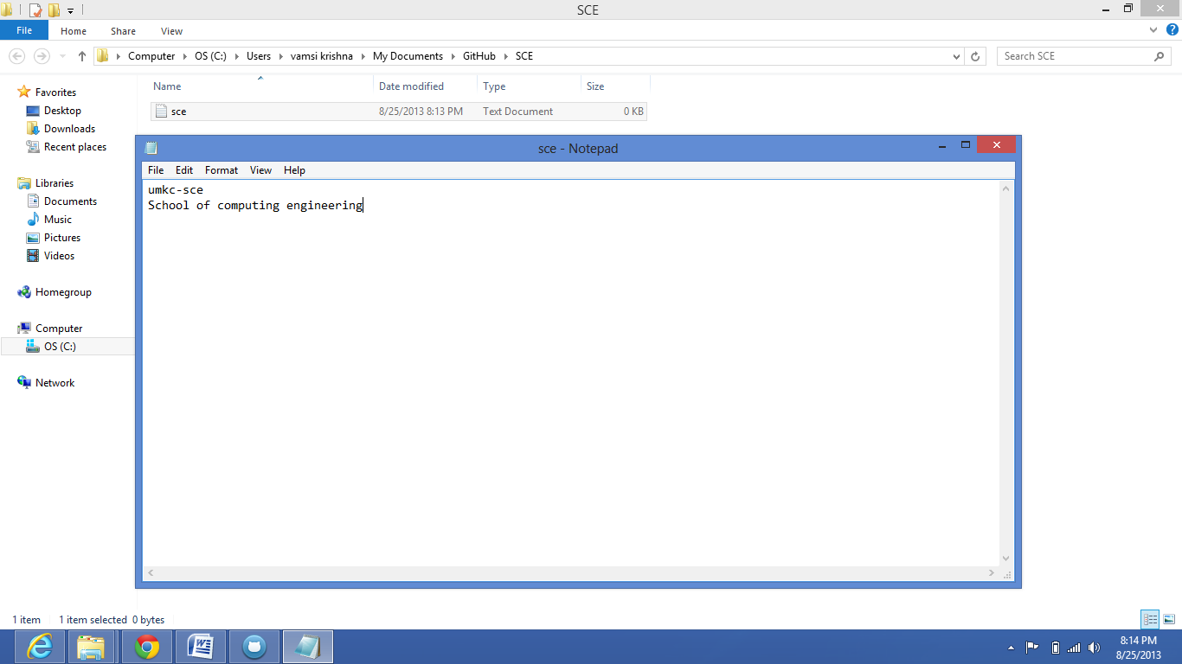

(S) INPUT COMMIT MESSAGES AND CLICK COMMIT

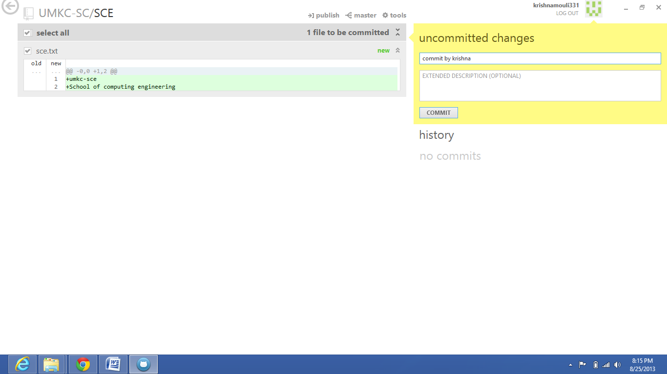

(T) CLICK THE PUBLISH AND THEN CLICK THE SYNC

